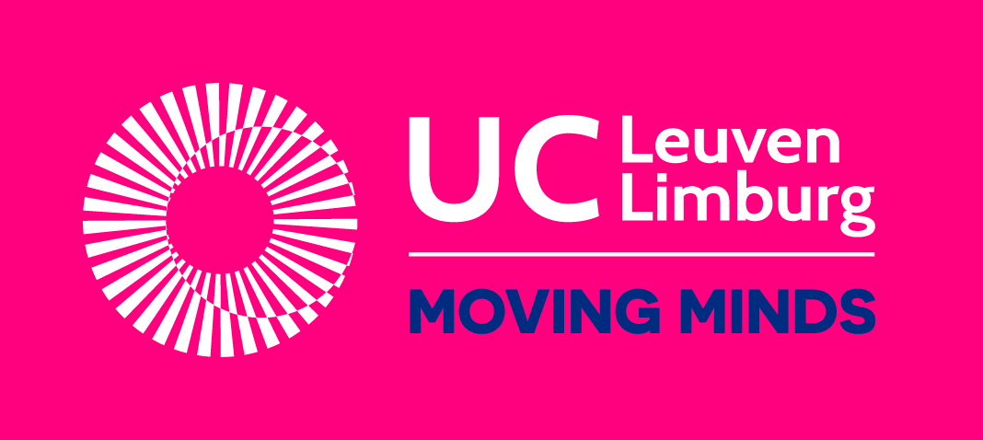
Impact of your employment

Baseline new employees

Dear employee,

This survey looks at the impact of your employment on your personal life and your relationships with others and society. We don’t want to evaluate you, we want to learn about the impact we can have as a company.

Your answers are stored on a separate secure server. Only your direct counselor will be able to see your answers, and this only if you explicitly give your permission at the end of the survey. Your answers will not be distributed further. Data from all surveys can be studied anonymously by us, to improve the company, or be used for research purposes.

Good to know

- There are no right or wrong answers. We just want to learn about your experience. If you do not want to answer one of the questions or if you do not know how, you can leave it open and go on to the next question.
- You are not required to participate. You can also stop at any time.
- If you feel bad or unhappy during or after the survey, you can always contact the researchers or someone you trust within the company.
- The survey will take 5 to 15 minutes to complete.

If everything is clear and you agree, please sign below. If you’re not sure whether you can agree, we advise you to discuss this first with someone you trust (e.g. a family member, a counselor from another organization,…)

I have understood everything and have received an answer to all my questions. I voluntarily agree to participate.

Name _____________________________ Date: __ /__/____

Signature:

In case of questions or remarks on the survey you can contact one of the researchers:
UC Leuven-Limburg
Stijn Custers Stijn.Custers@ucll.be 0474 035163 Expertisecentrum Smart Organisations
Eva Wuyts Eva.Wuyts@ucll.be 0488 091015 Campus Proximus
Geldenaaksebaan 335, 3001 Leuven

Who fills out the survey? Ask your counselor for help
Name of employee (First Name Last Name – it is very important to fill this is in correctly!)
________________________________

Part 1: How are you feeling?

For each statement you can select whether you “totally disagree”, “disagree”, “partly disagree”, “partly agree”, “agree”, or “totally agree”.

 | Totally disagree | Disagree | Partly disagree | Partly agree | Agree | Totally agree
- I am satisfied with my life
- I am happy with who I am
- I can be of significance to others
- I know what I can do well
- I have a positive outlook towards the future
- I have enough things to do on a day off
- I can get to work on my own
- I can pay my bills on my own
- I can take care of myself

Part 2: Your relationships with others

For each statement you can select whether you “totally disagree”, “disagree”, “partly disagree”, “partly agree”, “agree”, or “totally agree”.

 | Totally disagree | Disagree | Partly disagree | Partly agree | Agree | Totally agree
- I participate in activities outside of work and home
- Most people accept me for who I am
- I know people who are always there for me
- I sometimes feel alone

Part 3: Your quality of life

For each statement you can select whether you “totally disagree”, “disagree”, “partly disagree”, “partly agree”, “agree”, or “totally agree”.

 | Totally disagree | Disagree | Partly disagree | Partly agree | Agree | Totally agree
- I have enough money for my monthly costs (e.g. bills, groceries,…)
- Each month I have enough money left for extra’s (e.g. hobby’s, shopping, saving,…)
- I often worry about money
- I usually look forward to the day
- I am happy
- I feel too stressed
- I feel healthy
- My health makes it difficult to do what I have to do (e.g. job, housework,…)
- My house is safe to live in (no leaks, no fungus, enough space and light, no noise,…)

Part 4: How is it going with your job?

The following statements are about skills at work. You can think of work you used to do. If you have never worked, then answer how you think it will be for you at your new job here.

For each statement you can select whether you “totally disagree”, “disagree”, “partly disagree”, “partly agree”, “agree”, or “totally agree”.

 | Totally disagree | Disagree | Partly disagree | Partly agree | Agree | Totally agree
- I regularly learn new things at work
- I learn from my mistakes
- I try to do my work as best as I can
- I can solve problems at work on my own
- I can do my work without help from others
- I stay calm during stressful situations at work
- I am good at collaborating with others

To conclude

What do you expect will be the biggest change in your life when you start working here?

When was the survey filled out?
- at intake meeting (when discussing possible employment)
- at startup meeting (in preparation of employment)
- on the first day of employment
- at a later date

Support
- This survey was filled out without help
- This survey was filled out together with a counselor

Do you agree that after completing the survey your personal counselor at work receives a copy of your responses to discuss with you?
- yes, my personal counselor can receive a report of my responses
- no, I do not want my personal counselor to receive a report of my responses

You’ve reached the end of the survey! Thanks for your collaboration!
Do you have questions after completing the survey? Are you worried about something? Please contact your personal counselor at work or someone else you trust about this.

